# **Plan of the module**

1. Fundamentals of Machine Learning
2. Data preparation
3. Performance metrics
4. Under the hood
5. Model tuning
6. Workflow
7. Ensemble methods
8. Unsupervised learning
9. Time series
10. Natural Language Processing

# **Plan of the lecture**

1. What is Machine Learning?
2. Scikit-learn Library
3. Linear Regression with Scikit
4. Generalization - Holdout Bias Variance
5. Cross Validation
6. Learning Curves

# **1. What is Machine Learning?**

The area of computational science that focuses on analyzing and interpreting patterns and structures in data to enable learning, reasoning, and decision making outside of human interaction.

* Machine Learning is constantly and rapidly evolving
* Few standards are set in stone
* Stay tuned!

## **General programming vs. Machine Learning**



[Original source](https://www.sciencedirect.com/science/article/abs/pii/S1878875017316650), recreated by Bruncky

## **Machine Learning Taxonomy**

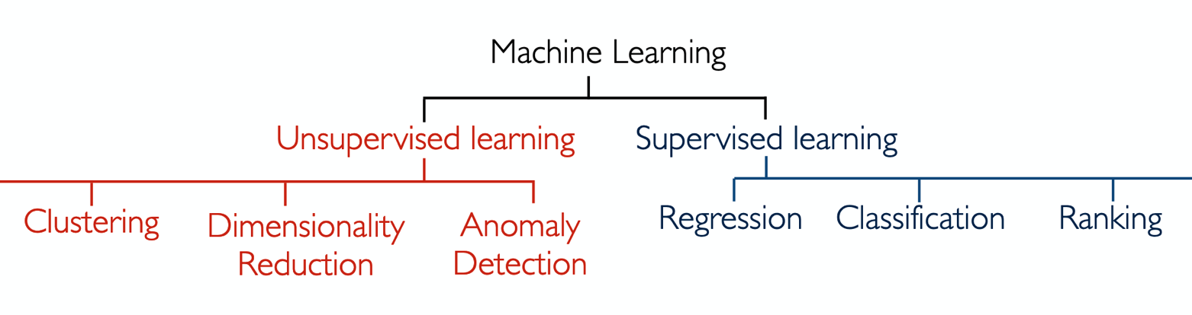

## **Supervised Learning**

Develop predictive model based on both input and output data.

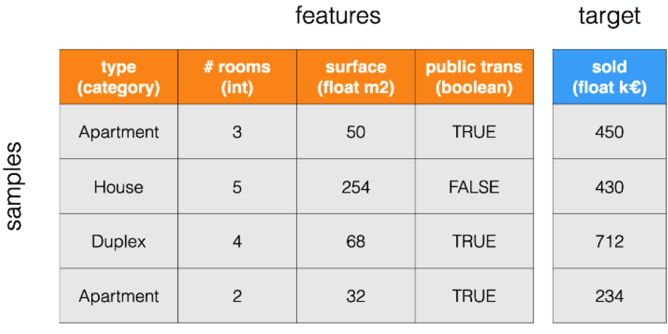

## **Classification vs Regression**

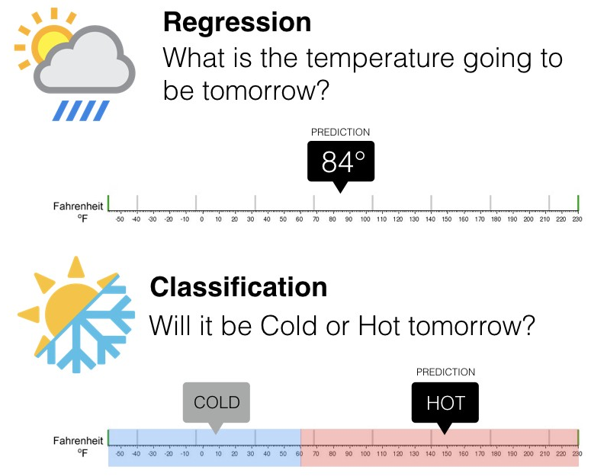

[Source](https://www.researchgate.net/figure/Example-of-classification-and-regression-problem-when-dealing-with-temperature_fig7_333221048)

## **Unsupervised Learning**

Group and interpret data based only on input data.

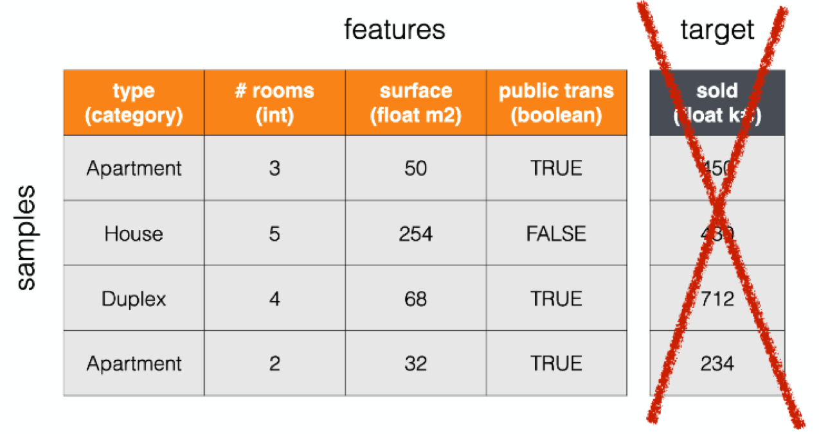

## **Jargon**

The **features** can also be referred to as the **input**, the **X's**, the **variables**.

The **target** can also be referred to as the **output**, the **y**, the **label**, the **class**.

The **samples** can also be referred to as the **rows** or the **observations**



## **ML stages**

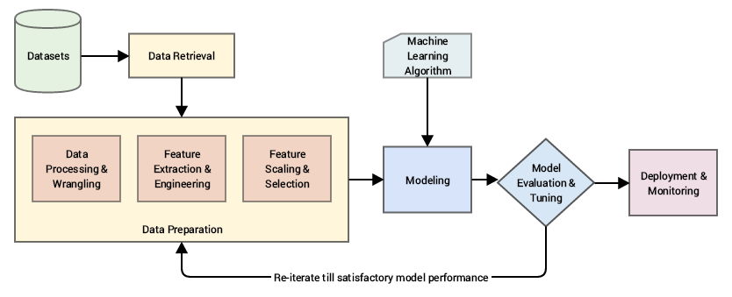

[Source](https://web2.qatar.cmu.edu/~gdicaro/15488/)

## **ML domains and tasks**

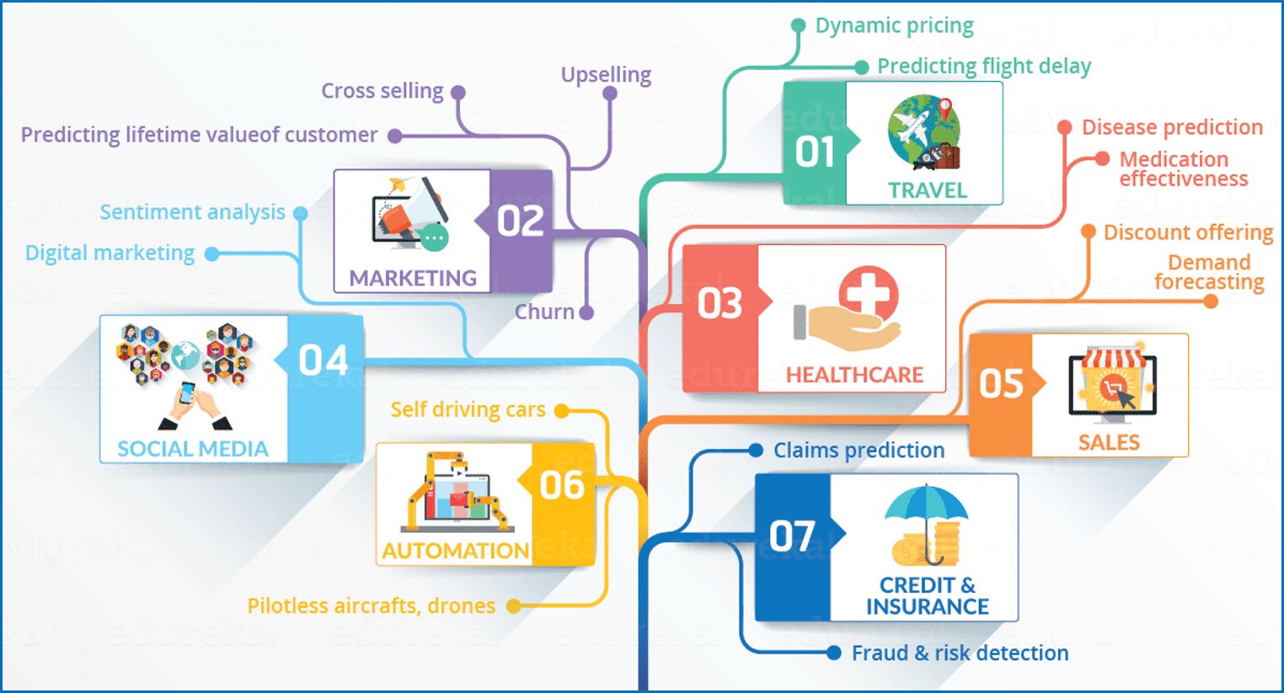

[Source](https://www.edureka.co/blog/what-is-machine-learning/)

# **2. Scikit-learn**



Scikit-learn (Sklearn) is a Machine Learning library that provides data preprocessing, modeling, and model selection tools.

👉 [https://scikit-learn.org](https://scikit-learn.org/)

## **Installing Sklearn**

In your terminal, type the following:

pip install scikit-learn

👉 [Installation Documentation](https://scikit-learn.org/stable/install.html)

## **Sklearn structure**

* Sklearn is organized by **modules**
* Each module contains tools in the form of **classes**

## **linear_model module**

* linear_model is a module
* LinearRegression is a class

👉 [Sklearn linear_model documentation](https://scikit-learn.org/stable/modules/classes.html#module-sklearn.linear_model)

## **Module and Class imports**

There are many ways to import modules and classes in notebooks, but there is a best practice.

🚫 **import** **sklearn** *# this will not work with sklearn*

model = sklearn.linear_model.LinearRegression() *# ❌*

🚫 **import** **sklearn.linear_model** *# import of entire module*

model = sklearn.linear_model.LinearRegression() *# must type library and module prefix every time*

🚫 **from** **sklearn** **import** linear_model *# import of entire module*

model = linear_model.LinearRegression() *# must type module prefix every time*

🚫 **from** **sklearn.linear_model** **import** * *# import of entire module*

model = LinearRegression()

##### ***"Explicit is better than implicit" - The Zen of Python***

✅ **from** **sklearn.linear_model** **import** LinearRegression *# explicit class import from module*

model = LinearRegression() *#=> we know where this object comes from*

# **3. Linear Modeling with Sklearn**

## **Linear Regression Recap**

A Linear Regression (OLS) maps a linear relationship between the input X and the output y. It optimizes slope a and intercept b by reducing the residuals between the actual y and the predicted y.

y

=

a

X

+

b

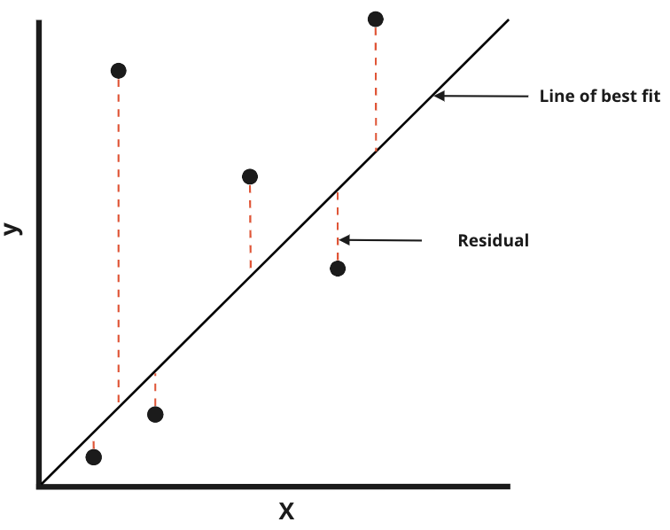

# **Logistic Regression recap**

Despite having "regression" in its name, Logistic Regression is actually a classifier. It uses a Sigmoid Function to map the probability of belonging to a class.

P

(

y

i

=

1

∣

X

)

=

1

1

+

e

−

(

β

0

+

β

1

x

)

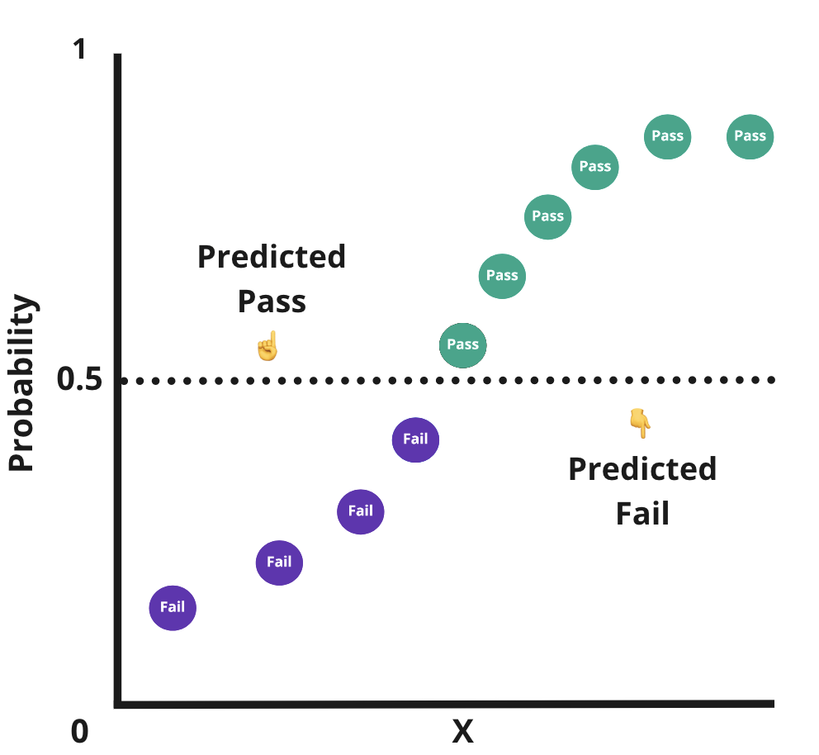

## **💻 Linear Regression with Sklearn**

Consider the following dataset ([download here](https://wagon-public-datasets.s3.amazonaws.com/Machine%20Learning%20Datasets/ML_Houses_dataset.csv)). It is a collection of houses and their characteristics, along with their sale price. The full documentation of the dataset is available [here](https://wagon-public-datasets.s3.amazonaws.com/Machine%20Learning%20Datasets/ML_Houses_dataset_description.txt).

**import** **pandas** **as** **pd**

data = pd.read_csv(file)

*# Shuffling the data*

data = data.sample(frac=1)

data.head()

|  | **Id** | **MSSubClass** | **MSZoning** | **LotFrontage** | **LotArea** | **Street** | **Alley** | **LotShape** | **LandContour** | **Utilities** | **...** | **PoolArea** | **PoolQC** | **Fence** | **MiscFeature** | **MiscVal** | **MoSold** | **YrSold** | **SaleType** | **SaleCondition** | **SalePrice** |
| --- | --- | --- | --- | --- | --- | --- | --- | --- | --- | --- | --- | --- | --- | --- | --- | --- | --- | --- | --- | --- | --- |
| **1557** | 358 | 120 | RM | 44.0 | 4224 | Pave | NaN | Reg | Lvl | AllPub | ... | 0 | NaN | MnPrv | NaN | 0 | 8 | 2007 | WD | Normal | 134000 |
| **1004** | 1005 | 120 | RL | 43.0 | 3182 | Pave | NaN | Reg | Lvl | AllPub | ... | 0 | NaN | NaN | NaN | 0 | 5 | 2009 | WD | Normal | 181000 |
| **1518** | 179 | 20 | RL | 63.0 | 17423 | Pave | NaN | IR1 | Lvl | AllPub | ... | 0 | NaN | NaN | NaN | 0 | 7 | 2009 | New | Partial | 501837 |
| **348** | 349 | 160 | RL | 36.0 | 2448 | Pave | NaN | Reg | Lvl | AllPub | ... | 0 | NaN | NaN | NaN | 0 | 10 | 2008 | WD | Normal | 154000 |
| **794** | 795 | 60 | RL | NaN | 10832 | Pave | NaN | IR1 | Lvl | AllPub | ... | 0 | NaN | NaN | Shed | 500 | 10 | 2008 | WD | Normal | 194500 |

5 rows × 85 columns

Let's start simple by modeling the SalePrice (y) according to the GrLivArea (X).

livecode_data = data[['GrLivArea', 'SalePrice']]

livecode_data.head()

|  | **GrLivArea** | **SalePrice** |
| --- | --- | --- |
| **1557** | 1142 | 134000 |
| **1004** | 1504 | 181000 |
| **1518** | 2234 | 501837 |
| **348** | 1626 | 154000 |
| **794** | 1895 | 194500 |

### **Exploration**

**import** **matplotlib.pyplot** **as** **plt**

*# Plot Living area vs Sale price*

plt.scatter(data['GrLivArea'], data['SalePrice'])

*# Labels*

plt.xlabel("Living area")

plt.ylabel("Sale price")

plt.show()

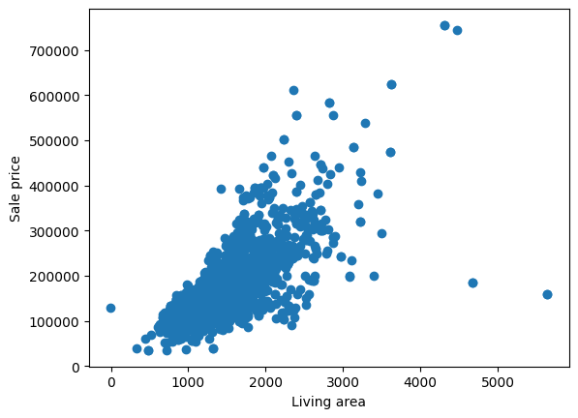

### **Training**

Training a Linear Regression model with Sklearn LinearRegression

*# Import the model*

**from** **sklearn.linear_model** **import** LinearRegression

*# Instantiate the model (💡 in Sklearn often called "estimator")*

model = LinearRegression()

*# Define X and y*

X = data[['GrLivArea']]

y = data['SalePrice']

*# Train the model on the data*

model.fit(X, y)

LinearRegression

LinearRegression()

👉 [Sklearn LinearRegression documentation](https://scikit-learn.org/stable/modules/generated/sklearn.linear_model.LinearRegression.html)

At this stage, the model has learned the optimal **parameters** - slope a and intercept b - needed to map the relationship between X and y.

### **Model Attributes**

a (slope) and b (intercept) are stored as model attributes and can be accessed.

*# View the model's slope (a)*

model.coef_

array([105.00927564])

*# View the model's intercept (b)*

model.intercept_

22104.121010020754

### **Scoring**

Each Scikit-learn algorithm has a default scoring metric.

LinearRegression uses the **Coefficient of Determination** (

R

2

) by default.

* R
* 2
* represents the proportion of the variance of the target explained by the features.
* The score typically varies between 0 and 1
* The higher score the better the model

*# Evaluate the model's performance*

model.score(X, y)

0.48960426399689116

💡 Different models will have different default scoring metrics. You can look them up in the [.score() method in the model's docs](https://scikit-learn.org/stable/modules/generated/sklearn.linear_model.LinearRegression.html?highlight=linearregression#sklearn.linear_model.LinearRegression.score).

For example, a classifier like LogisticRegression will default scoring to [accuracy](https://scikit-learn.org/stable/modules/generated/sklearn.linear_model.LogisticRegression.html?highlight=logisticregression#sklearn.linear_model.LogisticRegression.score).

### **Predicting**

The trained model can be used to predict new data

*# Predict on new data*

new_data = pd.DataFrame({'GrLivArea': [1000]})

model.predict(new_data)

array([127113.39664561])

👉 An apartment with a surface area of 1000

f

t

2

has a predicted value of about U$127K.

❗ Note that your X (features) almost always need to be a 2D-array when passed as an argument to an sklearn API method

## **Sklearn modeling flow**

1. Import the model: from sklearn import model
2. Instantiate the model: model = model()
3. Train the model: model.fit(X, y)
4. Evaluate the model: model.score(new_X, new_y)
5. Make predictions: model.predict(new_X)

❓ What did we do wrong when scoring the model's performance?

👉 We scored the model on the same data it was trained on!

# **4. Generalization**

The performance of a Machine Learning model is evaluated on its ability to **generalize** when predicting **unseen data**.

## **The Holdout Method**

The Holdout Method is used to evaluate a model's ability to generalize. It consists of splitting the dataset into two sets:

* **Training set** (~70%)
* **Testing set** (~30%)

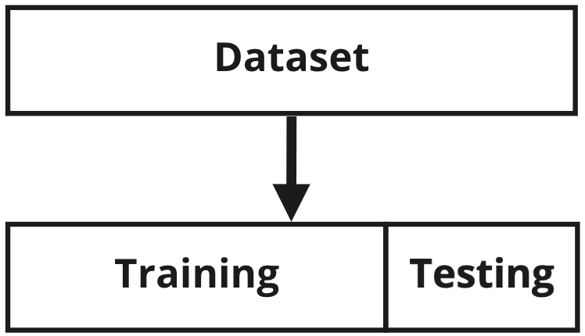

### **Example**

Imagine our dataset has 9 observations

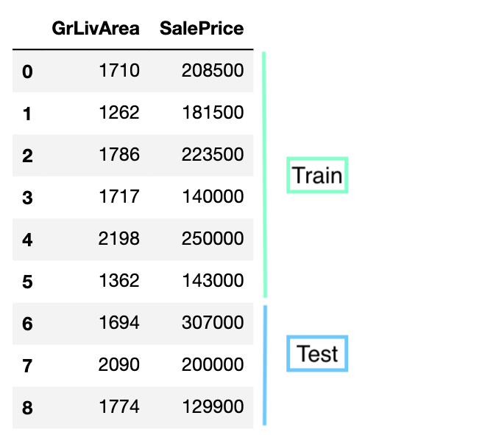

### **💻 train_test_split**

Let's model the SalePrice (y) according to the GrLivArea (X) whilst keeping generalization in mind.

livecode_data.head()

|  | **GrLivArea** | **SalePrice** |
| --- | --- | --- |
| **1557** | 1142 | 134000 |
| **1004** | 1504 | 181000 |
| **1518** | 2234 | 501837 |
| **348** | 1626 | 154000 |
| **794** | 1895 | 194500 |

### **Splitting**

**from** **sklearn.model_selection** **import** train_test_split

*# split the data into train and test*

train_data, test_data = train_test_split(livecode_data, test_size=0.3)

*# Ready X's and y's*

X_train = train_data[['GrLivArea']]

y_train = train_data['SalePrice']

X_test = test_data[['GrLivArea']]

y_test = test_data['SalePrice']

You could also directly pass X and y to train_test_split.

*# Ready X and y*

X = livecode_data[['GrLivArea']]

y = livecode_data['SalePrice']

*# Split into Train/Test*

X_train, X_test, y_train, y_test = train_test_split(X, y, test_size=0.3)

### **Training and scoring**

*# Instantiate the model*

model = LinearRegression()

*# Train the model on the Training data*

model.fit(X_train, y_train)

*# Score the model on the Test data*

model.score(X_test,y_test)

0.48189443216474215

❓Can you think about any limitations of the Holdout Method?

### **Data split is random**

Different random splits will create different results

*### RUN THIS CELL MULTIPLE TIMES TO SEE DIFFERENT SCORES*

*# Split into Train/Test*

X_train, X_test, y_train, y_test = train_test_split(X, y, test_size=0.3)

*# Instantiate the model*

model = LinearRegression()

*# Train the model on the Training data*

model.fit(X_train, y_train)

*# Score the model on the Test data*

model.score(X_test,y_test)

0.5246872071350943

We can use the random_state option, but we can be easily tempted to pick one with the best score 😈

### **Loss of information**

The data in the Test set is not used to train the model. If you have a small dataset, that loss could be significant!

❓ How would you solve that issue?

👉 Average the scores of multiple holdout splits.

## **K-Fold Cross Validation**

1. The dataset is split into number of folds K
2. For each split, a sub-model is trained and scored
3. The average score of all sub-models is the **cross-validated** score of the model

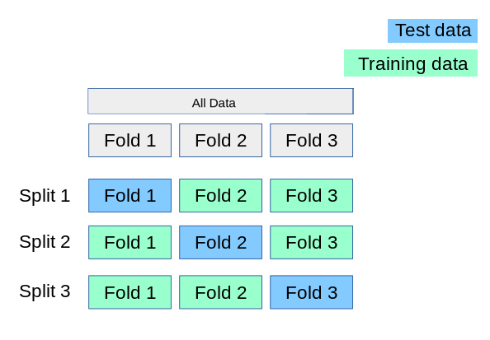

### **Dataframe view**

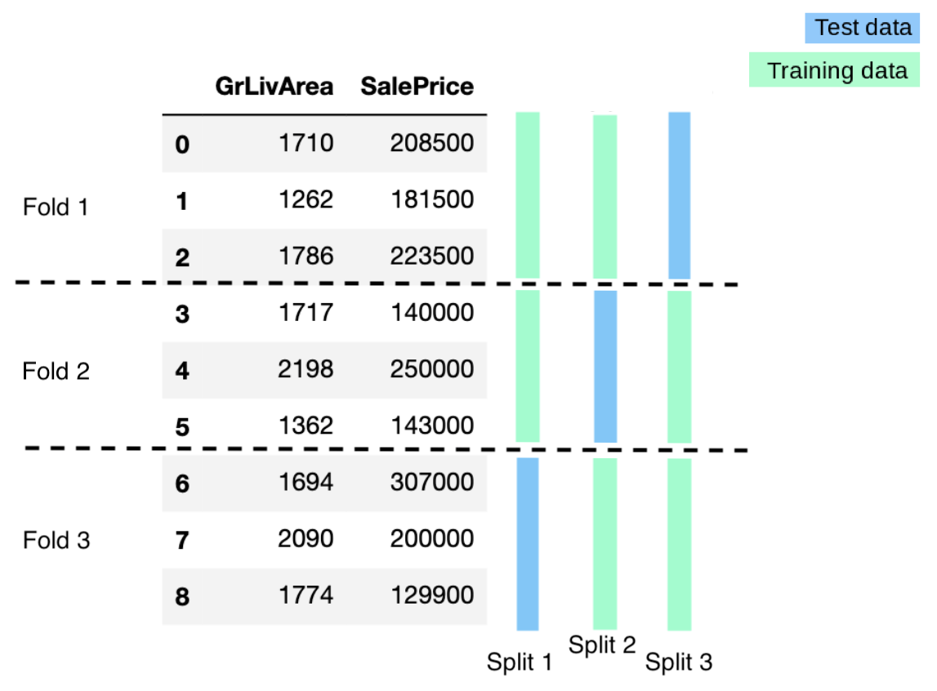

## **💻 cross_validate**

**from** **sklearn.model_selection** **import** cross_validate

*# Instantiate model*

model = LinearRegression()

*# 5-Fold Cross validate model*

cv_results = cross_validate(model, X, y, cv=5)

*# Scores*

print(cv_results['test_score'])

*# Mean of scores*

cv_results['test_score'].mean()

[0.29966592 0.43383776 0.552854 0.59169285 0.51451021]

0.47851215043151624

### **Choosing K**

* Choosing K is a tradeoff between trustworthy performance evaluation and computational expense
* More K-folds --> more sub-models to average scores from --> more representative score --> more computational time

ℹ️ Rule of thumb:

K

=

5

or

10

🚨 Cross-validation does not output a trained model, it only scores a hypothetical model trained on the entire dataset.

## **The Bias/Variance tradeoff**

For a model to generalize, there will be a tradeoff between **bias** and **variance**.

* **Bias (Underfitting)**: The inability for an algorithm to learn the patterns within a dataset.
* **Variance (Overfitting)**: The algorithm generates an overly complex relationship when modeling patterns within a dataset.

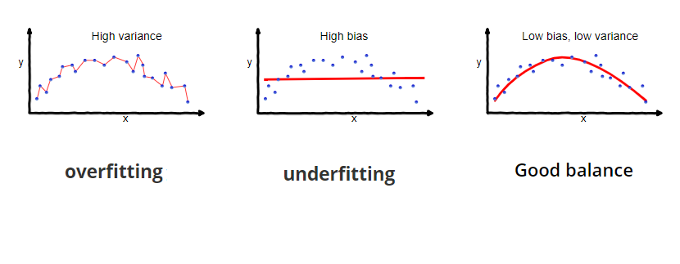

[Source](https://medium.com/towards-data-science/understanding-the-bias-variance-tradeoff-165e6942b229)

## **No Free Lunch Theorem**

Some models **oversimplify**, while others **overcomplicate** a relationship between the features and the target.

It's up to us as data scientists to make **assumptions** about the data and evaluate reasonable models accordingly.

**There is no one-size-fits-all model**, this is known as the [**No Free Lunch Theorem**](https://en.wikipedia.org/wiki/No_free_lunch_theorem).

## **The Learning Curves**

Learning curves are used to diagnose three aspects of model behaviour on the dataset:

* Underfitting
* Overfitting
* Whether the model has sufficient data to learn the patterns of the dataset

### **Concept**

Increasing the size of the training set can affect the training and validation scores.

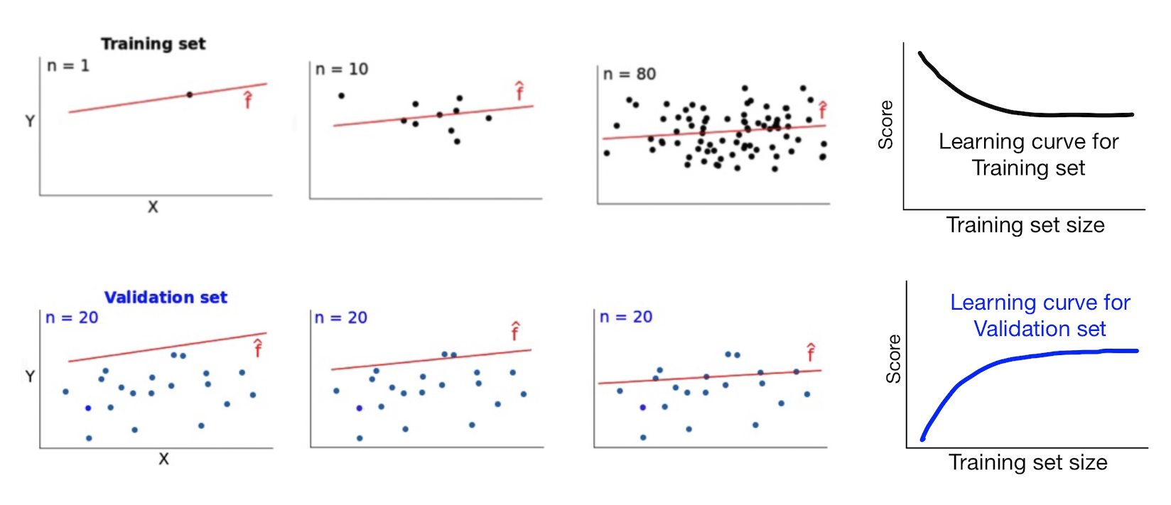

[Source](https://www.dataquest.io/blog/learning-curves-machine-learning/)

### **Reading the curves**

The two curves are plotted together on the same graph.

As the training size increases:

* The training score will decrease
* The test score will increase
* The curves typically (but not always!) demonstrate convergence

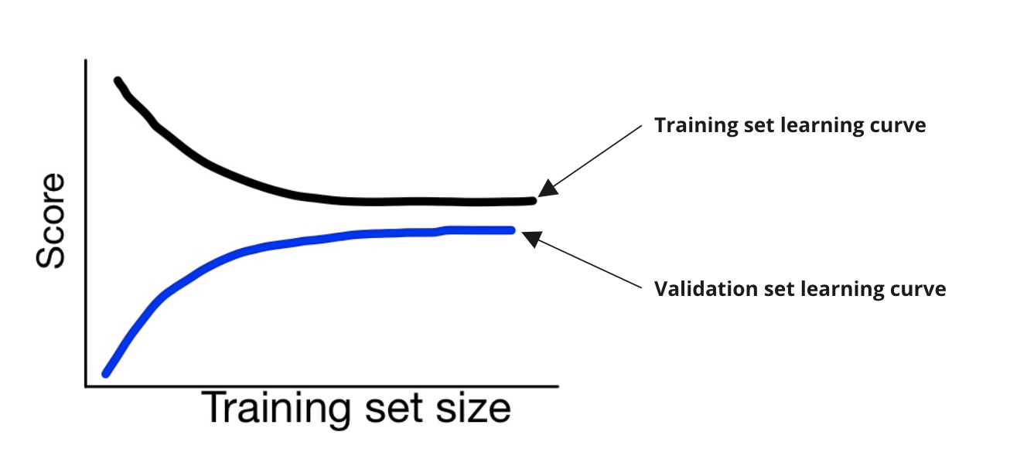

### **High bias (Underfitting)**

Low scores in **both** training and test sets.

If the model cannot determine a relationship in the training set, we cannot expect the model to score highly in the test set.

Training and testing scores converge and **plateau at a low score**. No matter how much data is used for training, the model cannot determine a meaningful relationship.

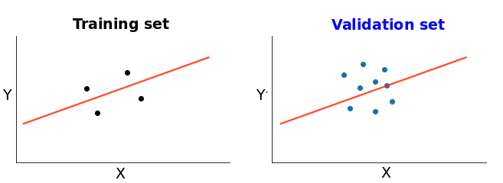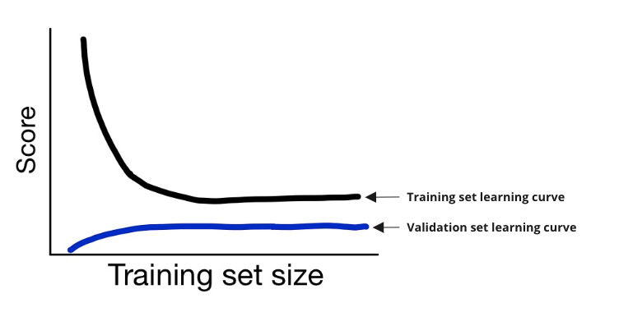

### **High variance (Overfitting)**

The model has paid **too much attention** to both signal and noise in the training data, leading to **high training scores**.

**Reliance on noise** does not generalize well on unseen data, resulting in **low test scores**. More training data *might* help in this case.

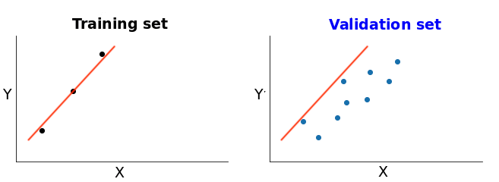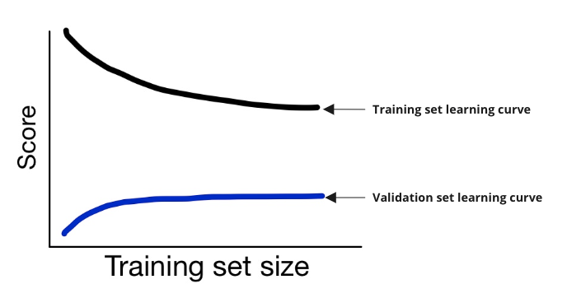

We're going to learn how to combat bias and variance in future lectures ⚔️

### **Ideal curves**

* High score on training set
* High score on test set
* Converged curves

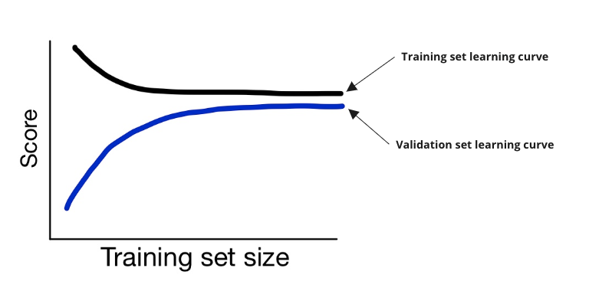

### **🖥 Learning Curves with Sklearn**

Let's plot and read the learning curves for our Regression model on house prices.

**import** **numpy** **as** **np**

**from** **sklearn.model_selection** **import** learning_curve

train_sizes = [25,50,75,100,250,500,750,1000,1150]

*# Get train scores (R2), train sizes, and validation scores using `learning_curve`*

train_sizes, train_scores, test_scores = learning_curve(

estimator=LinearRegression(), X=X, y=y, train_sizes=train_sizes, cv=5)

*# Take the mean of cross-validated train scores and validation scores*

train_scores_mean = np.mean(train_scores, axis=1)

test_scores_mean = np.mean(test_scores, axis=1)

*# plt.plot(train_sizes, train_scores_mean, label = 'Training score')*

*# plt.plot(train_sizes, test_scores_mean, label = 'Test score')*

*# plt.ylabel('r2 score', fontsize = 14)*

*# plt.xlabel('Training set size', fontsize = 14)*

*# plt.title('Learning curves', fontsize = 18, y = 1.03)*

*# plt.legend()*

### **Reading our curves 1/2**

👉 The two curves have converged and plateaued:

* The model is doing the best it can at finding the patterns within the data
* Adding more data will not improve its performance

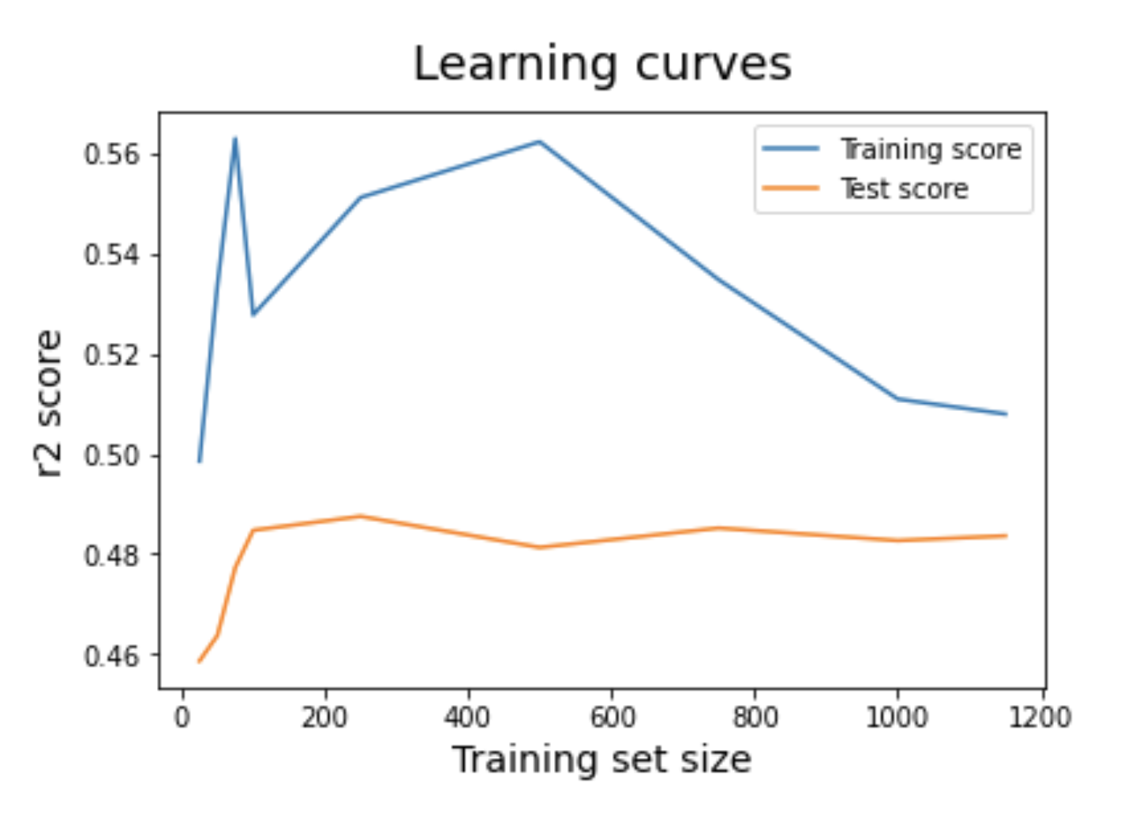

### **Reading our curves 2/2**

👉 The score is still relatively low (R2 around 0.5):

* It's up to us to try and improve this score while still maintaining generalization.
* You will learn how to do this in the exercises and in the next couple of lectures! 💪



# **Your turn! 🚀**